



Essay / Assignment Title: Designing a sales Tableau Dashboard for a chosen company

Programme title: Visualization and Story Telling using Tableau

Name: EMRE ÖZYÜREK

Year: 2024

CONTENTS

CONTENTS 2
INTRODUCTION 5
Problem: 5
Data Source: 6
Strengths of the Data: 6
Constraints of the Data: 6
Explaining the Data and Its Attributes: 6
FORMULATION 8
1.Additional Attributes Needed for Dashboard 8
2.Visual Elements for the Dashboard 9
IMPLEMENTATION 10
1. Importing Data into Tableau: 10
2. Creating Calculated Fields: 11
Total Revenue 11
3P Revenue 11
1P Revenue 12
1P Revenue per k Pageviews: 12
3P Revenue per k Pageviews: 13
Zero 13
3. Creating Visualizations: 14
Line Chart: Total Revenue Over Time 14
Bar Chart: 1P, 3P Revenue Over Time 14
Butterfly Bar Chart: Revenue per k Pageviews Over Time 16
DASHBOARD DESIGN 19
1. How to Put the Dashboard Together 19
2. Adding the Filters: 19
3. Styling and Formatting: 20
4.Making the Dashboard Public 21
Steps for Publishing: 21
DISCUSSION 22
1. Risks: 22
a. Data Quality Risks 22
b. Misinterpretation Risk: 22
c. Technical Risks: 23
2. Effectiveness of the Dashboard: 23
a. Key Benefits 23
b. Limitations 23
3. Future Improvements: 24
In-Depth Data Analysis: 24
Predictive Analysis 24
Extend Information to Region and Demographics Demographic Analysis: 24
Conversion Tracking and Attribution Models: 24
Better UX: User Role-Based Dashboards: 25
BIBLIOGRAPHY 26
APPENDIX 27
TABLE OF FIGURES 27

Statement of compliance with academic ethics and the avoidance of plagiarism

I honestly declare that this dissertation is entirely my own work and none of its part has been copied from printed or electronic sources, translated from foreign sources and reproduced from essays of other researchers or students. Wherever I have been based on ideas or other people texts I clearly declare it through the good use of references following academic ethics.
(In the case that is proved that part of the essay does not constitute an original work, but a copy of an already published essay or from another source, the student will be expelled permanently from the postgraduate program).

Name and Surname (Capital letters):

EMRE ÖZYÜREK
Date: 04/10/2024

INTRODUCTION

Problem:
In the advertising industry, performance analysis is highly important for firms, especially online classified advertisements. Measuring the performance gap between 1P and 3P ads, tracking demand over ads, impression rate, click-through rate, and revenues may be crucial to optimize the advertising strategy.
1P Advertising (first-party advertising)
1P stands for the First Party. In this sense, 1P refers to a brand or manufacturer selling their items directly to a platform such as Amazon or Walmart, which then sells them to the customer. The platform functions fundamentally as a shop. For example, if you are a company that sells directly to Amazon, Amazon will purchase your products at wholesale costs and resell them under its own name. When it comes to advertising, 1P has usually used its own solutions to sell its products. Sponsored Brands or Display Ads can boost visibility and revenue.
3P (Third-Party Advertising)
3P stands for Third Party. In this case, a brand or seller acts as a third-party seller on the platform., listing and selling their products directly to consumers. In this case, the seller has to handle most aspects of the transaction: inventory management, pricing, and possibly shipping. 3P advertising still happens on platforms like Amazon or Walmart, but the ads specifically promote products sold directly by the third-party seller. These are merchants who use platform-specific advertising services, such as Sponsored Products or Sponsored Brands, to increase the visibility of their products or other forms of advertising.
This project's objective is to create a dashboard that will enable them to monitor ad performance for 3P and 1P ads, segmented by period, for the platform.
By analyzing the data, we will find answers to the following questions:
- Performance by Ad Type: How can we compare the revenues, such as Total, 3P, and 1P?
- Trends Over Time: How can we track seasonal changes and trends in ad performance?
- Ad Effectiveness: Can we analyze which ad types are more effective with metrics such as 1P - 3P Rev per k Pageviews?

Data Source:
Our data is a weekly ad performance data from an online classified advertising company in Germany for the year 2023. This dataset includes column headings that track 1P and 3P ad performance. It also includes information on ad demands, impressions, clicks, and revenues for both 1P and 3P for Display and PLA ad types.

Strengths of the Data:
Comprehensive Advertising Information: The advertising strategy of 1P and 3P advertising data can be compared.
Key Metrics: Demand, impressions, clicks, revenues, etc. are some of the key performance indicators available.
Suitable for Time Series Analysis: The information is in such a format that it can be analyzed across time dimensions, thus being able to show the trend.

Constraints of the Data:
The data could have no information on the regions that viewed the ads.
Some records could be lost or even incorrect and, therefore, might need data cleaning.
Demographic information could be incomplete regarding the specific customer/viewer profile.

Explaining the Data and Its Attributes:
Our Dataset includes the following columns:
Date: Timestamp of each record. Data are weekly.
Unique ID: Unique IDs are generated every week.
1P Display Ad Requests: The overall ad requests for 1P Display ads, i.e., visual.
1P Display Impressions: Number of impressions for how many 1P Display Ads were viewed.
1P Display Clicks: Total clicks on 1P Display Ads.
1P PLA Ad Requests: Overall ad requests for 1P PLA Ads.
1P PLA Impressions: Impressions of 1P PLA Ads.
1P PLA Clicks: The total clicks on 1P PLA ads.
3P Display Ad Requests: The total ad requests for 3P Display ads.
3P Display Impressions: Impressions of 3P Display ads.
3P Display Clicks: Clicks on 3P Display ads.
3P PLA Ad Requests: The total ad requests for 3P PLA ads.
3P Display Impressions: Impressions of 3P Display ads.
3P PLA Impressions: Impressions of 3P PLA ads.
3P PLA Clicks: Clicks on 3P PLA ads.
1P Display Revenue: Revenue through 1P Display ads.
1P PLA Revenue: Revenue through 1P PLA ads.
3P Display Revenue: Revenue from 3P Display ads.
3P PLA Revenue: Revenue from 3P PLA ads.
Page Views: Total number of page views on the website.
Visits: Number of visits to the website.

FORMULATION

1.Additional Attributes Needed for Dashboard
Although the columns in our dataset already are good to go for simple metrics and analysis, some calculated fields and filters need to be added to the model in order to get more profound analysis and sharper visualizations. Those will be necessary to slice ad performance from different angles. Here are some additional features that we may need:
• Total Revenue:
1P and 3P total revenue calculation.
Formula: Total Revenue = 1P Display Revenue + 1P PLA Revenue + 3P Display Revenue + 3P PLA Revenue
• 3P Total Revenue
Calculating 3P total revenue using PLA and Display revenue
Formula: 3P Total Revenue = 3P PLA Revenue + 3P Display Revenue
• 1P Total Revenue
Calculating 1P total revenue using PLA and Display revenue
Formula: 3P Total Revenue =1P PLA Revenue + 1P Display Revenue
• Revenue per k Pageviews:
Calculation: Revenue / Pageviews (per 1000 views).
To provide revenue per pageview analysis.
Formula: Revenue per k Pageviews = (Total Revenue / Page Views) * 1000

2.Visual Elements for the Dashboard
This dashboard has to present data in such a way that it is more comprehensible, using several visual elements. The basic visual elements to use are:
• Line Charts:
Line charts can be used to track how metrics change over time.
• Bar Charts:
To compare total revenue for different ad types, such as 1P PLA versus 3P Display, and so on.
Example: Total revenue by ad type can be shown as a bar chart.
• Stacked Bar Charts:
These are good for comparing revenue for both 1P and 3P ad types.
Example: Distribution of 1P and 3P ad revenue by quarter or month.
• Filters:
Time Filter: Expose data as per month, quarter.
Ad Type Filter: To filter by ad type 1P/3P.

IMPLEMENTATION

During this step, we create the elements needed for the dashboard using the data and the additional calculated fields in Tableau.

1. Importing Data into Tableau:
Step 1: Launch Tableau, select "Connect to a File," and select Excel as the location of our dataset.
Step 2: Our dataset is imported.
Step 3: The Data Source tab allows us to examine our data when it has finished loading. After that, we verified that the column headings corresponded with the fields we would require.
Step 4: The 'Date' column's type is defined as a date.
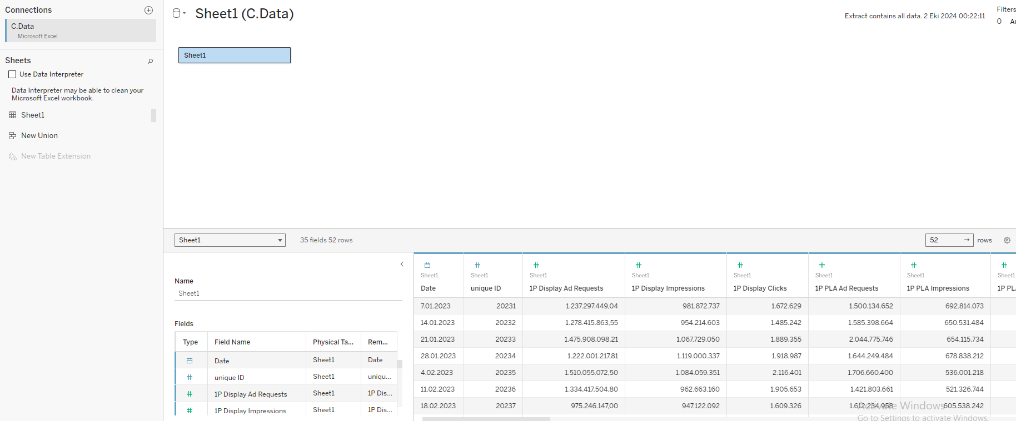
Figure 1

2. Creating Calculated Fields:
We will create other calculated fields as needed for analysis and visualization.

Total Revenue
We clicked on the analysis tab on the left tab, then clicked on create calculated field in the list. Then we entered the formula. Finally, we clicked on complete.
Formula:
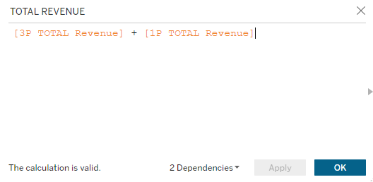
Figure 2

3P Revenue
Then, we clicked the tab 'create calculated field' in the list on the left tab. We then entered the formula and clicked complete.
Formula:
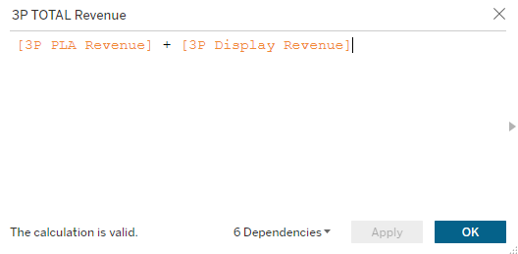
Figure 3

1P Revenue
We clicked the analysis tab on the left tab, then click create calculated field in the list. Then we entered the formula. Then we clicked complete.
Formula:
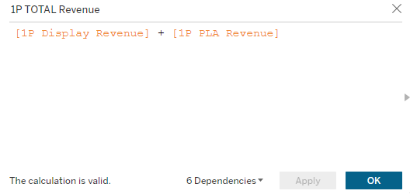
Figure 4

1P Revenue per k Pageviews:
We clicked on the left tab, the analysis tab, then clicked on 'create calculated field' in the list. Then we entered the formula. Finally, we clicked on complete.
Formula:
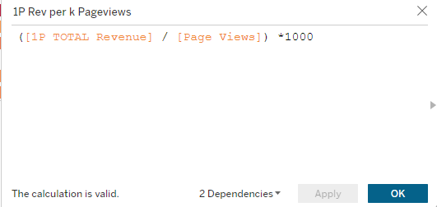
Figure 5

3P Revenue per k Pageviews:
We clicked on the analysis tab on the left tab then clicked on create calculated field in the list. Then we entered the formula. Finally, we clicked on complete.
Formula:
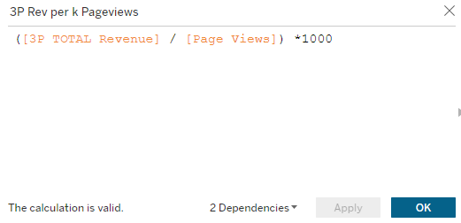
Figure 6

Zero
Then, we clicked the tab 'create calculated field' in the list on the left tab. We then entered 0 and clicked complete.
Formula:
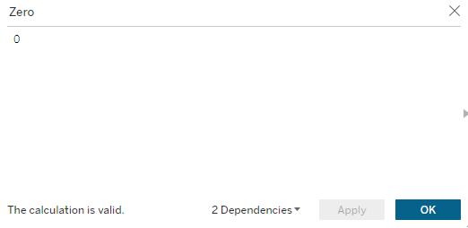
Figure 7

3. Creating Visualizations:

Line Chart: Total Revenue Over Time
Step 1: Drag Date to Columns.
Step 2: Drag 'TOTAL REVENUE' (calculated field) to Rows.
Step 3: Change the chart type to Line Chart by clicking the chart options at the top.
Step 4: Add color differentiation for each line metric.
Step 5: Add labels and filters for monthly/quarterly analysis.
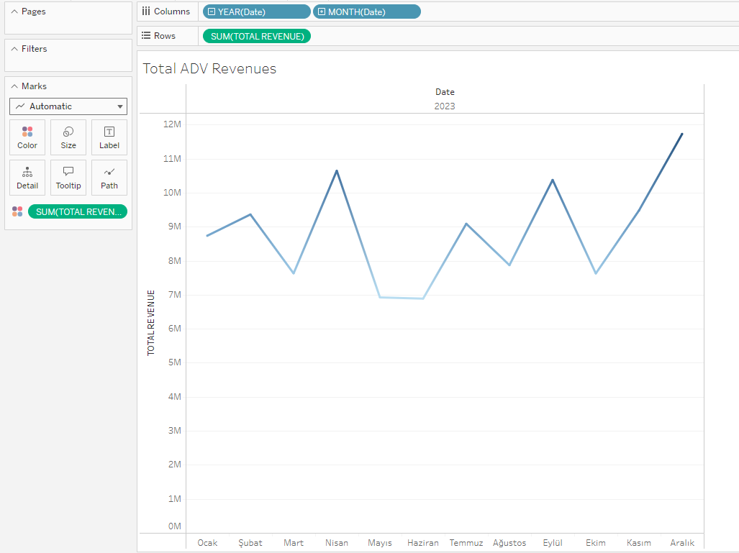
Figure 8

Bar Chart: 1P, 3P Revenue Over Time
Step 1: We dragged Date to the Columns shelf.
Step 2: We dragged '1P or 3P' (calculated field) to the Rows shelf.
Step 3: We changed the chart type to Bar Chart by clicking the chart options at the top.
Step 4: We added color distinction for each line metric.
Step 5: We added labels and filters for monthly/quarterly analysis.
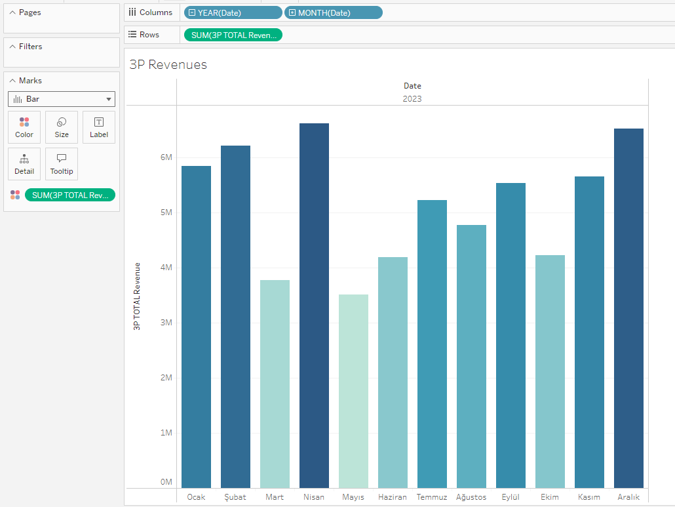
Figure 9
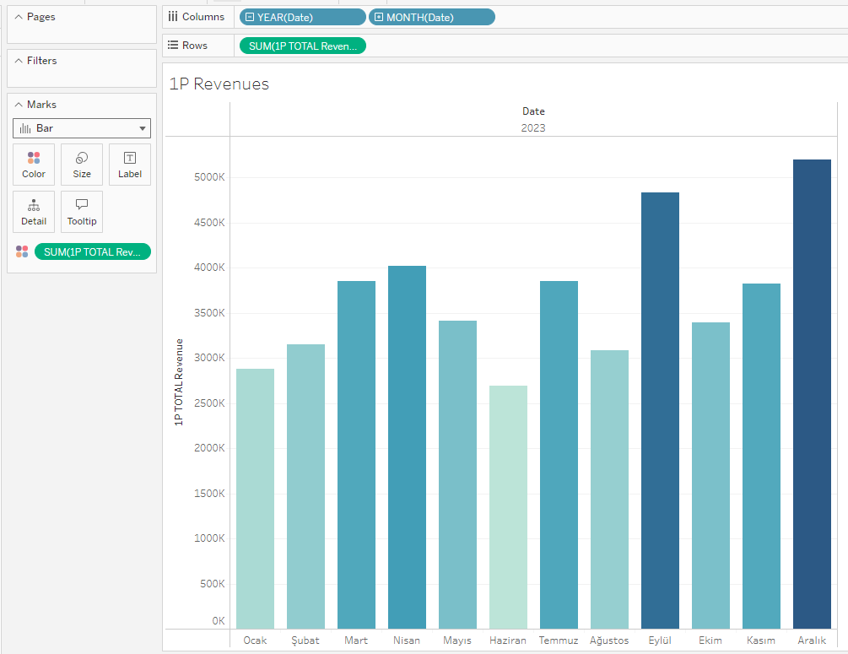
Figure 10

Butterfly Bar Chart: Revenue per k Pageviews Over Time
Step 1: We dragged Date to the Rows shelf.
Step 2: We dragged '3P Revenue per k Pageviews' and '1P Revenue per k Pageviews' (calculated fields) to the Columns shelf.
Step 3: We changed the chart type to Bar Chart by clicking the chart options at the top.
Step 4: We clicked edit axes and clicked 'Reversed Axes'.
Step 5: We dragged 'Zero' calculated field to the Columns section and between other calculated fields.
Step 6: We dragged Date to Label in the Marks - Sum(Zero) section.
Step 7: We clicked to hide the header on rows.
Step 8: Add color distinction for each line metric.
Step 9: Adding relevant labels and filters for monthly/quarterly analysis.
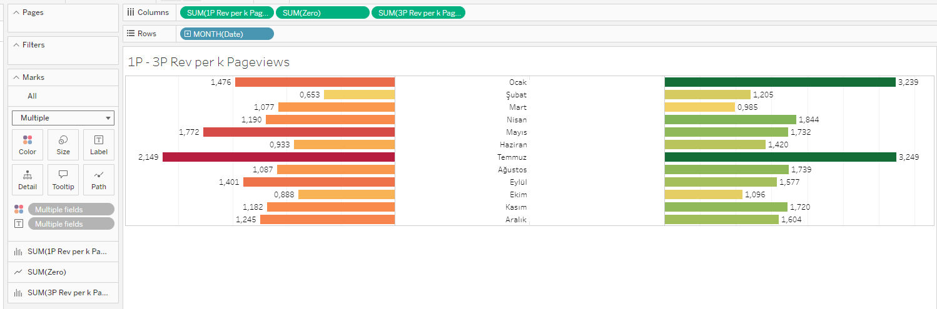
Figure 11
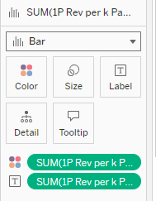
Figure 12
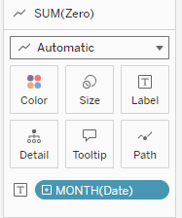
Figure 13
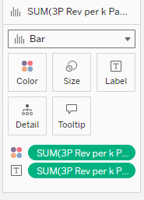
Figure 14

DASHBOARD DESIGN

Combine all the charts, KPIs, and images that were given across the many work sections into one, making sure it satisfies the requirements of Task 1; hence, an organized Tableau dashboard will be created. The work will be rounded off by setting filters, actions, and interactivity to make the dashboard user-friendly and informative.

1. How to Put the Dashboard Together
Step 1: I chose the New Dashboard icon in the bottom area of Tableau.
Step 2: Dragged the generated sheet one by one, including the line, bar, and butterfly bar charts, into the dashboard configuration.
Step 3: Created a new sheet to be able to portray the understanding in showing the Total Revenues at the top right side. Then, drag it on to the dashboard.

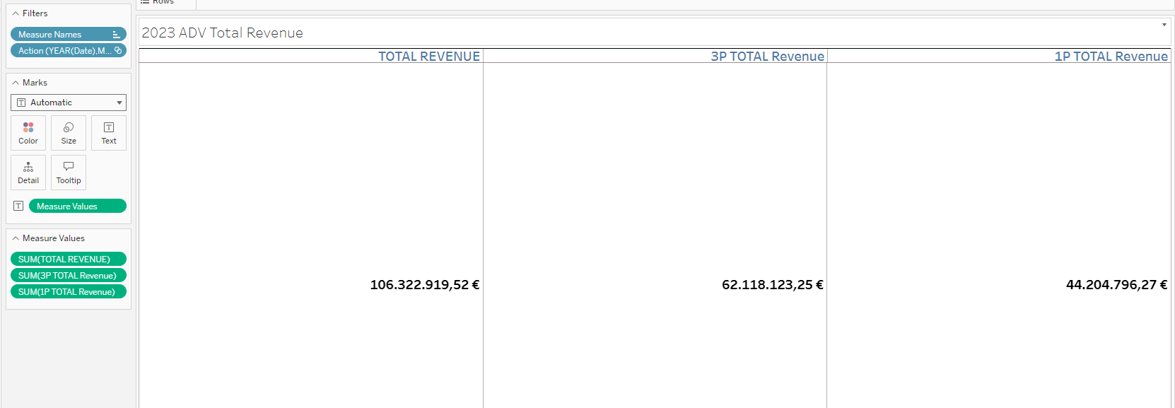
Figure 15
Step 4: Ensuring they are pleasing to the sight and easy to view.

2. Adding the Filters:
Step 1: Added interactive filters for Date and Ad Type allow users to interact with the dashboard.
Step 2: Ensured the filters are synchronized across all charts.

3. Styling and Formatting:
Step 1: Customized fonts, colors, and backgrounds to make the dashboard visually appealing.
Step 2: Added titles for better user understanding.
Step 3: Used consistent color schemes to differentiate between 1P and 3P metrics.
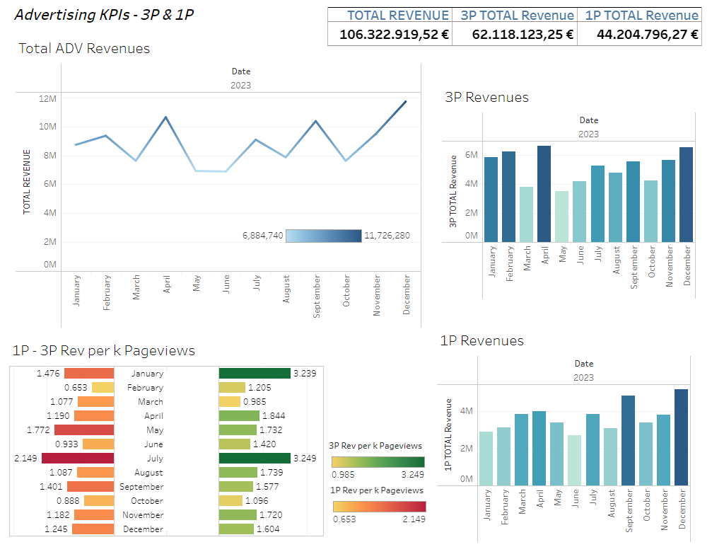
Figure 16

4.Making the Dashboard Public
After adding the required interactive filters and actions to the visual elements, this is the last stage.

Steps for Publishing:
- Verifying for Errors:
Examined our dashboard to ensure that the charts, computed fields, and filters are all operating as they should. Verified the veracity of the information gathered in several areas, such as income totals and impressions.
- Dashboard Exportation:
We exported our dashboard as a Tableau with others online. (Profile link: https://public.tableau.com/app/profile/emre.ozyurek/viz/ADVDATA/Sheet1)

DISCUSSION

1. Risks:
There are several factors that contribute to the overall quality, precision, and usefulness of insights to be derived from this during the development and usage of this dashboard. The source could either emanate from problems with the data, purely technical, or even user perception.

a. Data Quality Risks
Incorrect/Incomplete Data:
The data the dashboard will be based on may contain missing values, errors, or other such inconsistencies that would lead to faulty results and analysis from the dashboard. Revenue data for some months might be missing, for example.
Risk Aversion:
We should do as much data cleansing as possible before analysis and automate error checking where possible.
Data Lag or Outdated Information:
Where refresh of data is not done, the dashboard might start showing performance indicators based on information that might be stale. This can lead to incorrect decisions.
Mitigation: We need to set up regular data refresh schedules so that the most recent figures are always represented in the dashboard.

b. Misinterpretation Risk:
User Misunderstanding:
This occurs when people misread the insights or do not understand how to apply the filters/actions offered in the insights. The system ends up giving wrong results for that matter.
Mitigation:
We need clearly to label the data, use tooltips, and document how someone is supposed to interact with the dashboard.

c. Technical Risks:
Performance Issues:
Performance may be slow, hence not responsive, due to large volumes involved and complex calculations. It can basically be mitigated by reducing the load times through the application of various performance optimization techniques available in Tableau, which include summarizing data, efficient calculated fields, and filtering strategies.

2. Effectiveness of the Dashboard:
The Tableau dashboard provides valuable insights for executives on product and ad performance across time, ad kinds, and locations. Its efficacy will be measured in terms of serving the demands of its users and decision makers while better detecting trends, patterns, and possibilities.

a. Key Benefits
Full Perspective:
This provides a high-level overview of the business performance by showing an overview of the performance metrics, such as Total Revenue, 1P-3P Revenue per k Pageviews, and more.
Interactivity: Filters, drill-down actions, and navigation tooltips improve interactivity in the dashboard for users to set up their view based on their preferences; users can drill down further into specific details.
Comparative Insights:
In the dashboard, it will be easy for them to determine what advertising strategies bring them more money by comparing the performance of different types of advertisements; that is 1P and 3P.
Real-time Data Exploration:
Effortlessly explore trends overtime such as Monthly, Quarterly compare them with intuitive charts and graphs to make decisions more insightful.

b. Limitations
Data Granularity:
Lack of granularity in the dataset-incomplete daily data or region-specific breakdown, for example-means that the derived insights will not be granular enough to support micro-level decisions.
Excessive dependence on historical data: The dashboard has a huge bias towards historical data, and this may sometimes not give the right indication regarding how the future would be. Many external factors, such as market changes or new ad formats, might not be signaled.

3. Future Improvements:
Although the current dashboard offers some benefit, it may serve better for pinpointing specific areas of growth.

In-Depth Data Analysis:
More daily or hourly data can show the exact trend and patterns, like the time when ads work best.
Enhancement: Add daily/hourly filters and breakdowns to give even more granular performance data.

Predictive Analysis
Predictive Capabilities:
Introduce predictive analytics and forecasting models; project future performance based on historical trends. Use ARIMA models or Tableau's built-in forecasting tool to project future revenues.
Enhancement: Include charts and models for the prediction of the trend in the future to facilitate the user in forecasting and efficiently planning the utilization of resources.

Extend Information to Region and Demographics Demographic Analysis:
In case the data includes demographic information, say age and gender, it will provide extra insight into which segments do best for which type of ads.
Enhancement:
By offering demographic variable filters, we can get more personalized and targeted insights.
Regional performance:
Add a geographic map visualization to the dashboard that shows revenue and performance by country or region. Can be used to track performance across regions.

Conversion Tracking and Attribution Models:
Conversion Analysis:
Tracking the path from ad impressions to conversion, like a purchase or a sign-up, will be of immense help. Moreover, it can utilize conversion tracking and attribution models like last click and linear for finding out which ad creative formats bring the most value in terms of return on investment.
Value: Complementing the end-to-end view of ad performance, we can add metrics for conversions and perform attribution analyses.

Better UX: User Role-Based Dashboards:
Various stakeholders may want to see different insights in the data, such as marketing teams, finance, and executives. Solution: Users have the ability to create custom dashboards or dashboard views based on user roles. Example: Finance dashboard with metrics about revenue.

BIBLIOGRAPHY

- Meyer, B.C. and Bishop, D.S. (2022). A lesson in Tableau dashboard design: Playing the beer game with a real‐time data connection. Decision Sciences Journal of Innovative Education. doi:https://doi.org/10.1111/dsji.12264.
- Bach, B., Freeman, E., Abdul-Rahman, A., Turkay, C., Khan, S., Fan, Y. and Chen, M. (2022). Dashboard Design Patterns. IEEE Transactions on Visualization and Computer Graphics, [online] 29(1), pp.1–11. doi:https://doi.org/10.1109/tvcg.2022.3209448. ‌
- Google Books. (2014). Communicating Data with Tableau. [online] Available at: https://books.google.de/books?hl=tr&lr=&id=zoHOAwAAQBAJ&oi=fnd&pg=PR2&dq=tableau+dashboard+design&ots=ab-dvN5B8_&sig=Fu_dUCATFMm-oBDfAyDyzVd5Z8w&redir_esc=y#v=onepage&q=tableau%20dashboard%20design&f=false [Accessed 6 Oct. 2024]. ‌
- Bei, Z. and Gielens, K. (2022). EXPRESS: The One-Party Versus Third-Party Platform Conundrum: How Can Brands Thrive? Journal of Marketing, 87(2), p.002224292211168. doi:https://doi.org/10.1177/00222429221116803.
- Hong, X., Xu, L., Du, P. and Wang, W. (2015). Joint advertising, pricing and collection decisions in a closed-loop supply chain. 167, pp.12–22. doi:https://doi.org/10.1016/j.ijpe.2015.05.001.

APPENDIX

TABLE OF FIGURES
Figure 1 9
Figure 2 10
Figure 3 10
Figure 4 11
Figure 5 11
Figure 6 12
Figure 7 12
Figure 8 13
Figure 9 14
Figure 10 15
Figure 11 16
Figure 12 16
Figure 13 17
Figure 14 17
Figure 15 18
Figure 16 19

